

Using Remote Sensing and GIS to Analyze NDVI Values for

Darfur, Sudan

STUDENT HANDOUT

Part 1: Overview of Topic
In 2003, a conflict began to arise in the western region of Sudan between armed Arab camel-herding nomads called the Janjaweed joined with the Sudanese military against non-Arab farmers and rebels from the Fur, Zaghawa, and Massaleit ethnic groups. The current death toll from this conflict range from 200,000 to nearly 500,000 with estimates of over 2.5 million displaced. On September 9, 2004, Secretary of State Colin Powell acknowledged that the Sudanese conflict was genocide, and in September 2004 the UN Security Council passed a resolution to look into the conflict; but on January 31, 2005, the UN stated that the intent of this genocide could not be determined and, thus, was not genocide.

Though the conflict is militant, the likely cause of the humanitarian crisis—and the focus of this learning unit—is the water conflicts between farmers needing water for their crops and the nomads needing water for their cattle that have been caused by recent droughts and possible onset of regional desertification. One way scientists monitor changes in vegetation using remote sensing is by analyzing the near infrared radiation reflected by photosynthesizing plants using the Normalized Difference Vegetation Index (NDVI). Plants under stress, for example because of drought conditions, will produce less chlorophyll through photosynthesis and, thus, reflect less near-infrared radiation which results in a lower NDVI value.

By the end of this learning unit, students should be able to:
- Describe remote sensing and how NDVI analysis is used.
- Explain the geographic method along with its similarities and differences with the scientific method.
- Understand the causes of drought and desertification, specifically in Darfur, Sudan.
- Download specific MODIS data imagery using GloVis from the United States Geologic Survey (USGS) and load it into ArcMap 10 for analysis.
- Analyze monthly NDVI data for 2008 in the Darfur region to determine the wet and dry seasons for the region.
- Analyze NDVI values for the wet month – the month of September – in the Darfur region from 2000 to 2008 to determine if the genocide occurred during a dry period for the region as many suggest.
- Load the NDVI values into GIS to create a map showing the NDVI values for the region.
- Correlate the relationship between precipitation patterns and NDVI values based on the GIS.
- Explain how water shortages influenced and perhaps initiated the 2003 genocide in Darfur, Sudan.
- Analyze before and after satellite imagery to observe the actual destruction of villages caused by the invasion of the Janjaweed nomad militias into the non-Arab farmlands.

Geographers have a particular process for helping them think about issues or regions spatially, and it’s called the geographic method. Similar to the scientific method, the geographic method is a process that is used for thinking spatially. Begin by reading a brief article from ESRI called Geographic Inquiry: Thinking Geographically, which can be found online at http://www.esri.com/industries/k-12/pdfs/geoginquiry.pdf. Throughout the assignment, reflect on the following spatial questions:
- What is the geographic question for this assignment?
- What geographic resources did you acquire to complete this assignment?
- In what ways did you explore the geographic data?
- What information did you acquire by analyzing the data?
- How can the information you just learned be applied to a local, regional, or global level?

Part 2 – Introduction to NDVI Analysis, Drought, and Desertification

It is important to first note that for this assignment you will need to turn in two maps along with a worksheet that can be found in Appendix B at the end of this handout. So make sure you have the worksheet with you throughout the assignment so you don’t have to backtrack.

Some believe that the genocide in Darfur, Sudan, initially began because of drought conditions and possibly desertification. If this is true, it has been suggested that climate change could cause other regions of the world to also become politically unstable and, thereby, increase human rights violations such as genocide. The purpose of Part 2 is to help you acquire a basic knowledge of droughts, desertification, and NDVI analysis before beginning the activity. Also, consider how and why NDVI values are used as an early warning system for severe droughts and food security. Read the following articles from NASA’s Earth Observatory and begin to fill out the first portion of the Assignment Worksheet (at the end of this learning unit or provided by the instructor).

- Defining Desertification
http://earthobservatory.nasa.gov/Features/Desertification/
- Drought: The Creeping Disaster
http://earthobservatory.nasa.gov/Features/DroughtFacts/
- Measuring Vegetation (NDVI & EVI)
- http://earthobservatory.nasa.gov/Features/MeasuringVegetation/

Go to assignment worksheet (at the end of this document) to answer questions 1 and 2

Part 3 – File Management and Obtaining MODIS NDVI Imagery
Step 1: Managing folders and files.
You are going to be downloading a lot of imagery via the MODIS import tool. So let’s spend some time and do some data management.
- Ask your instructor where you need to save your files.
- In the location determined by your instructor, create a folder titled DarfurAssign. It is important to note that NOTHING in the file structure can have spaces, so do not create a folder on your Desktop! Also note how the folder was titled with no spaces. Follow this rule throughout the assignment – no spaces! Rather, combine words or use underscores to separate words.
- Within the Darfur folder create a folder titled MODIS (again no spaces).
- Create a folder titled Darfur2008.
- Create a folder titled Sept00_Sept07

From the NASA website on MODIS http://modis.gsfc.nasa.gov/about/ MODIS (or Moderate Resolution Imaging Spectroradiometer) is a key instrument aboard the Terra (EOS AM) and Aqua (EOS PM) satellites. Terra's orbit around the Earth is timed so that it passes from north to south across the equator in the morning, while Aqua passes south to north over the equator in the afternoon. Terra MODIS and Aqua MODIS are viewing the entire Earth's surface every 1 to 2 days, acquiring data in 36 spectral bands, or groups of wavelengths (see MODIS Technical Specifications). If you have not learned about MODIS in a class lecture or other assignment, take a few minutes to view the website to learn more about MODIS.

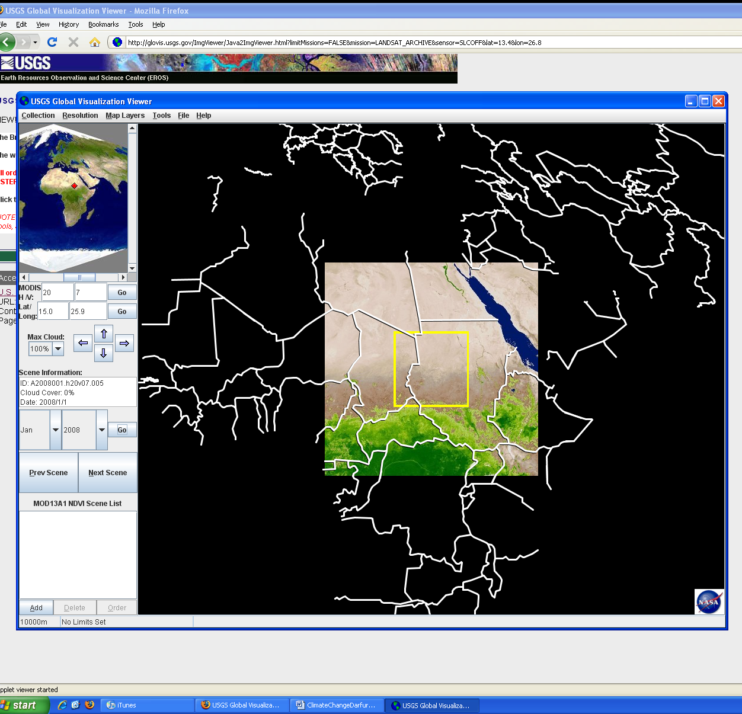
There are a number of ways to obtain MODIS data. The USGS GloVis website is the main site. While you will import the data into ArcGIS 10, in a different manner, it is useful to become familiar with the GloVIS website, so we will take a few minutes to do this.

Step 2: Explore MODIS data on GloVis.
- Go to http://glovis.usgs.gov/ and click on western Sudan in Africa. (NOTE: You will need to allow for pop-ups because GloVis will “pop up” another window to download imagery.)
- Next in the window titled USGS Global Visualization Viewer, go to Collection >> MODIS Terra >> MOD13A1 NDVI. Note how it changes the perspective of the map. That is because the GloVis default displays Landsat imagery, but you just changed the satellite to MODIS.
- Use the arrows and make sure the yellow box is over northwestern Sudan (see image on the right). More specifically, make sure your H/V is 20/7. It may also help to visually see what you are looking at by adding national boundaries by going to Map Layers >> Country Boundaries.
- When you are done exploring, close GloVis
NOTE: Downloading MODIS imagery is no different than downloading Landsat imagery.

Step 3: Obtain MODIS Toolbox from Esri Resource Center for importing MODIS data into ArcGIS10.

- Go to www.esri.com. Click on the Support topic. In the search box, enter MODIS Toolbox. The first result in the list should be the MODIS Toolbox | ArcGIS Resource Center. Click on it to go to the MODIS Toolbox page.
- This toolbox is freely downloadable. Click on the Download button. When the Save As dialog comes up, navigate to your DarfurAssign folder. Right click inside the DarfurAssign folder to create a new folder named Tools. Save the zip file inside the tools folder.
- Unzip the zip file, extracting inside your Tools folder. A folder named MODIS_Tools will be automatically created that contains documentation, scripts and the MODIS toolbox.
- This tool will enable us to download the NDVI imagery we will use, directly from USGS.
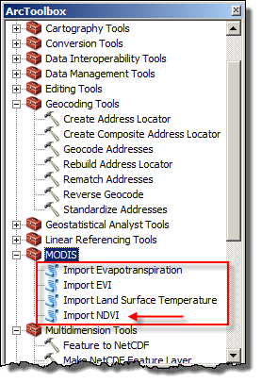
Step 4: Bring the toolbox into ArcGIS10
- Open a new blank ArcMap. Save as Darfur.mxd.
- Open ArcToolbox. In the ArcToolbox window, right click on the top ArcToolbox icon and click on Add Toolbox. In the Add Toolbox dialog navigate to your DarfurAssign\Tools\MODIS_Tools and select MODIS.tbx. Then click on Open. Notice that a new Toolbox, named MODIS, has been added to the list of toolboxes in ArcToolbox. Save your project.
Note: This toolbox will now be part of your Darfur project. If you start a new project, you will need to add the toolbox again.
Step 5: Import MODIS Terra data from January 2008 to ArcMap.
- Open the MODIS Toolbox. Notice there are four Python Scripts inside. You will use the Import NDVI script. Double-click on it to open the Import NDVI dialog box.
Note: The NDVI images that you will use are averaged for the entire month.
- Fill out the Import NDVI dialog as shown below to import the January 2008 MODIS image.
- Satelite: Terra, Month 01/2008, Tile h20v07 (refers to the scene of the image).
For the Output Raster, click on the yellow folder icon to the right of the Output Raster input line. When saving the output raster (MODIS NDVI image), you will likely need to first add a connection to your DarfurAssign folder in order to navigate to the correct location for saving. Save the image to your DarfurAssign\MODIS\Darfur2008 folder. Name it Jan2008_NDVI. Click Save, then OK to run the script.
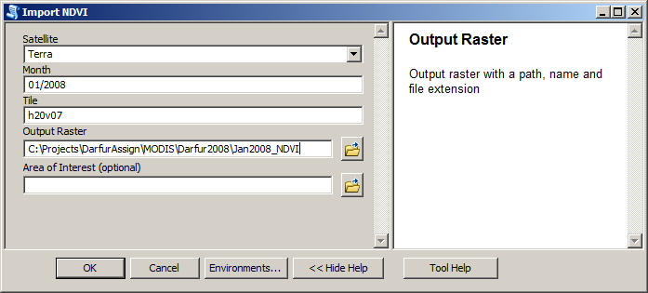

Note: The MODIS tool uses the Scratch folder in the MODIS_Tools folder during processing. You must have write privileges to this folder. If you rerun the operation for the same month, you must clear out this folder first. If you receive an error message, look to see if this is the problem.

- Repeat Step 5 to import the image for each month in 2008. Everything in the Import dialog will be the same except for the date and the output raster will have the name of the month.
You might find it helpful to checkmark as you go along to be sure you get them all imported. Double-check the folder when you are done, in ArcCatalog.

  - Jan2008_NDVI
  - Feb2008_NDVI
  - Mar2008_NDVI
  - Apr2008_NDVI
  - May2008_NDVI
  - Jun2008_NDVI
  - Jul2008_NDVI
  - Aug2008_NDVI
  - Sep2008_NDVI
  - Oct2008_NDVI
  - Nov2008_NDVI
  - Dec2008_NDVI

- Organize the Table of Contents by right-clicking on Layers and selecting New Group Layer and naming it MODIS 2008 Monthly. Move all of the NDVI images into it, so that your Table of Contents (TOC) looks like the one, on the next page.
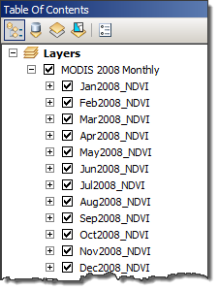
Step 6: Import seven years of MODIS data for September (highest average NDVI month in 2008)
- Now follow the same process, but this time import imagery from 2000 to 2007 for just September (i.e. September 2000, September 2001, September 2002, etc.), saving to the Sept00_Sept07 folder. Be sure to use the Terra Satellite and for tile: H20v07, when filling out the Import NDVI Dialog box.
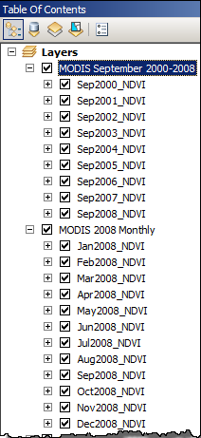
  - Sep2000_NDVI
  - Sep2001_NDVI
  - Sep2002_NDVI
  - Sep2003_NDVI
  - Sep2004_NDVI
  - Sep2005_NDVI
  - Sep2006_NDVI
  - Sep2007_NDVI

- Create a New Group Layer, naming it MODIS September 2000-2008. Move all of the September NDVI images into it that you just imported. Then, in the MODIS 2008 Monthly group layer right-click on the Sep2008_NDVI image and select Copy. Then, right-click on the MODIS September 2000-2008 group layer, right-click and select Paste. Organize the layers so they are in order as shown, to the left.
- SAVE

Part 4 – NDVI Analysis for Western Sudan from January-December 2008

Step 1: Next we need to record the mean NDVI value for each of the images, beginning with Jan2008.
- Open the image layer properties → Source. Scroll down to view the Statistics:

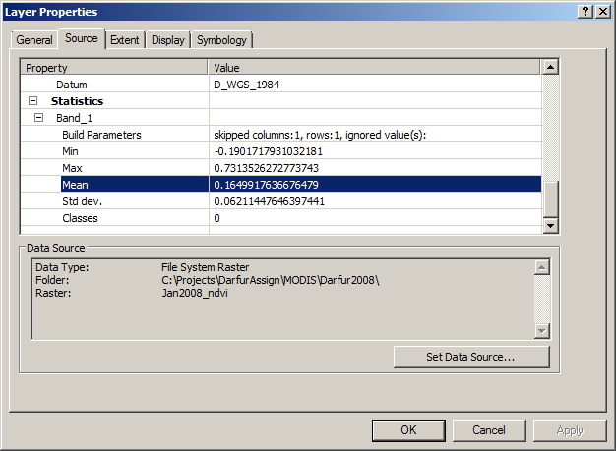
- The value you are focusing is the Mean value. NDVI values are between -1 (no vegetation) and 1 (high density of green vegetation). An NDVI of zero indicates no green vegetation.
- Add that average NDVI value (to the fourth decimal place) to your assignment worksheet (located at the end of this document) for Q3.
- Record the highest and lowest NDVI values for 2008 on your assignment worksheet.

Step 2: Repeat step 1 to find the Mean value for the rest of the 2008 MODIS images.
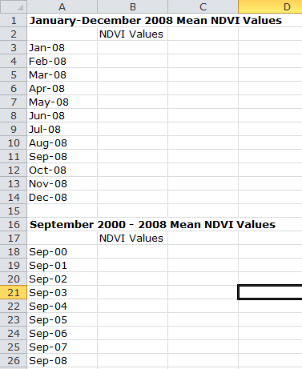
- Record the average NDVI value for Feb2008_NDVI through Dec2008_NDVI on your worksheet.

Step 3: Now we need to input the mean NDVI values for this image into Excel.
- Open up a blank Excel worksheet.
- Following the screenshot to the left, create an Excel template for inputting mean NDVI values for January-December 2008.
- After you have done that, create another column as shown for the September 2000-2008 values. We will be adding these values later in the assignment.

Step 4: Once all the mean NDVI values have been added to the Excel sheet, you will create a bar graph to visually represent the values.
- Creating a graph in Excel is fairly easy. Once the mean NDVI values are entered, highlight the month cells and Mean NDVI values columns, including the Mean NDVI Value title (NOT the January-December 2008 Mean NDVI Values title).
- These instructions are for Excel 2010. If you have an earlier or later version, your steps will be different.
- In Excel 2010, click on the Insert menu, then the Charts icon. Select the Column, then 2-D Cluster type.
- The graph will be added to the spreadsheet. The NDVI values should be on the Y-axis and the months in the X-axis.
- Click on the Chart Title to select it. Change it to Mean NDVI Values for January-December 2008. Change the font size to 14.
- Save the Excel document to your DarfurAssign Folder. You’ll be coming back to it later.

Part 5: NDVI Analysis for Western Sudan for September from 2000-2008

So far you have been analyzing NDVI values for every month in 2008. The goal was to analyze when NDVI values were highest in a given year and infer that the highest NDVI values correlate to the peak annual precipitation for the Darfur region. Now, we are going to repeat the entire process for the Modis data that you imported for the month of September from 2000 to 2008 (i.e. Sep2000, Sep2001, Sep2002, etc.) The goal now is to analyze NDVI values during peak annual precipitation time over the course of eight years to see if there was a drop in NDVI values, thus, a drop in precipitation causing a drought prior to the genocide.

Step 1: View the MODIS image for Sep2000.
- Back in your ArcGIS project, turn off the MODIS 2008 Monthly Group layer (uncheck mark just the group layer name).
- In the MODIS September 2000-2008 group layer, the Sep2000_NDVI layer should appear first and thus be the one that you view in the ArcMap display area.
- It should look like the one, below.
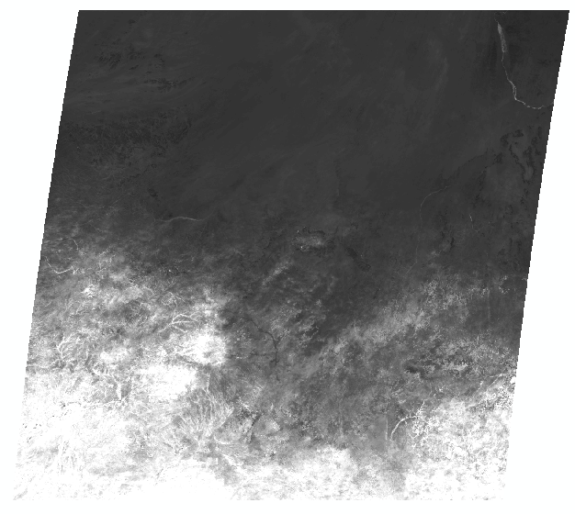

Step 2: Next we need to record the mean NDVI value for each of the September images, beginning with Sep2000_NDVI.
- Open the image layer properties → Source. Scroll down to view the Statistics:
- As in the 2008 monthly images, the value you are focusing is the Mean value. Recall once again that NDVI values are between -1 (no vegetation) and 1 (high density of green vegetation). An NDVI of zero indicates no green vegetation.
- Add that average NDVI value (to the fourth decimal place) to your assignment worksheet for Q4.

Step 3: Repeat step 2, 1-3 for the rest of the September MODIS images.
- Record the average NDVI value for Sep2000_NDVI through Sep2008_NDVI on your worksheet.

Step 4: Now we need to input the mean NDVI values for this image into Excel.
- Open up your Excel worksheet from earlier.
- Type the mean NDVI value – to the fourth decimal place – for Sep2000_NDVI in the cell. Record the highest and lowest NDVI values for September on your assignment worksheet.

Step 5: Repeat steps 2-4 for the rest of the Sep2001_NDVI through Sep2008_NDVI.

Step 6: Once all the mean NDVI values have been calculated and added to the Excel sheet, you will need to create a graph to visually represent the values.
- Once the mean NDVI values are entered, highlight the yearly September cells and Mean NDVI values columns for them, including the Mean NDVI Value.
Reminder: These instructions are for Excel 2010, so if you have a different version, your steps will be a little different.
- Click on the Insert menu, then the Charts icon. Select the Column, then 2-D Cluster type.
- The graph will be added to the spreadsheet. The NDVI values should be on the Y-axis and the months in the X-axis.
- Click on the Chart Title to select it. Change it to Mean NDVI Values for September 2000- 2008. Change the font size to 14.
- A graph should show up on the Excel sheet showing the mean NDVI values in the Y-axis and the months in the X-axis.

Part 6: Prepare to create Map Layouts of results in ArcGIS
Step 1: Examining the Low and High NDVI 2008 images.
- If your Darfur.mxd project is not open, open it. Turn off all of the images, except for Apr2008_NDVI and Sep2008_NDVI, the low and high NDVI months for 2008.
- Right-click on the Apr2008_NDVI image and select Properties. In the General tab, rename the low layer (April 2008) as April 2008 – Low average NDVI. In the Symbology tab, change the Color Ramp to something more appealing, such as the Brown Light to Dark. In the In the Stretch Type box, click on the drop-down box confirm that the type is set to Standard Deviations. Click OK.
- Click on the Identity tool and click around on the image. Your values should range from -1 to 1. Do the values make sense with the image?
- Turn off the April 2008 – Low average NDVI, then repeat 2 and 3 above for the Sep2008_NDVI image. Name it: September 2008 – High average NDVI. Be sure that both images use the same Color Ramp.
- SAVE

Step 2: Adding Basemaps and data from ArcGIS online
- Right-click on any of the images in the TOC and select Zoom to Layer. This is important to set the extent for the data that you are going to add from ArcGIS online.
- ArcMap comes with the capability of adding various basemaps from esri via the “Add Data” button. Click on the small arrow on the right side of the Add Data button and select Add Basemap…

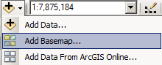
Note: If you don’t have an internet connection, your instructor will instruct you on where the data resides for this exercise.
- When the Add Basemap dialog comes up, select Imagery, then click Add. It will take a minute as the data does not reside “locally”. Once the data is added, you will see that a group layer is added to your TOC, which has the Imagery checked, and the Boundaries and Places and Transportation layers turned off.
- Right-click on the Imagery layer that you just added and select Properties. Read the Description to see where the data comes from. To find out specifically where it is from for the area we are studying, click the identify button anywhere on the image (not over the MODIS image). Be patient as it is retrieving information from the ArcGIS server and it will take a minute. You should see that the data comes from i-cubed. In the Description from the layer properties, you will see that i-cubed is derived from 15m eSAT imagery at medium to large scales (down to 1:70,000 for the world).
- Compare your low and high NDVI images to this basemap. Do you think it most resembles the low or the high? Your colors will be different, but you should be able to see where the vegetated areas are most similar to the low NDVI one.
- Turn off the two MODIS layer groups, so that you are only viewing the esri imagery basemap. Turn on the Boundaries and Places layer. Change the map scale to 1:6,000,000 to see more detail.
- Click on the Add Data button and select Add Data from ArcGIS Online…. When the dialog comes up, type World Cities in the search box and click on the magnifier icon to begin the search. Then scroll down until you see World Cities. Click on Add.
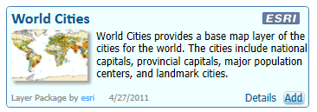
- On your own, add Major World Rivers to the map. The Nile River should be displayed to the right side of your map. Your map should look like the one, below.
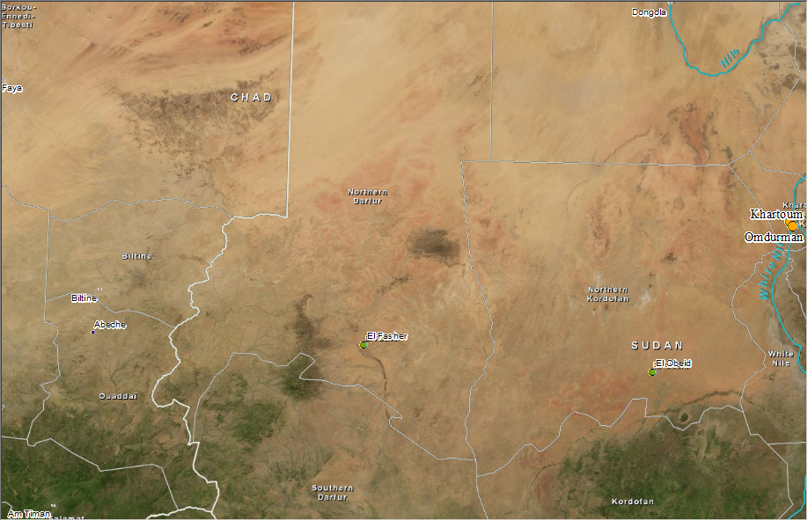

- On your own, add World Administrative Divisions to the map. Don’t worry about the color, as you will be modifying the layer in the next step.

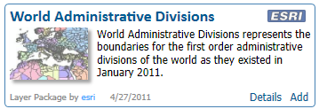
Step 3: Let’s now do a simple query in the Attribute Table to isolate Sudan in the Countries layer so you are able to clearly see that both Northern and Southern Darfur are in Sudan.
- Right-click on the World First Order Admin layer and click on the Attribute Table.
- Take a minute and analyze the Attribute Table. Which field would be best for the label “Sudan”?
- Now click on the Select by Attributes button.
- In the Select by Attributes box, select the field that names Sudan (i.e. Country) by double-clicking on it. Next click on the = symbol once. Now click on Get Unique Values and double-click on Sudan. Your final expression in the box should look something like “CNTRY_NAME” = ‘Sudan’ and click Apply.
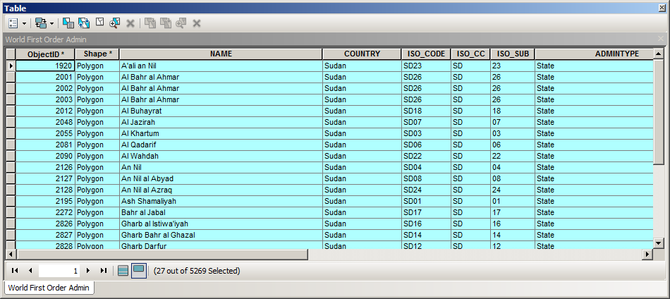

- Close the Attribute Table and you will find Sudan highlighted. Now right-click on your World First Order Admin layer (the countries layer), click on Selection, and then Create Layer From Selected Features. A new GIS layer will appear at the top of your GIS layers.
- Double-click on the new layer’s color symbol to bring up the Symbol Selector. Make the newly created layer Hollow with an Outline Width of 2.0 Rename the new layer Sudan. When you are done, remove the World First Order Admin layer.
- Make sure the box is checked on your Low NDVI Value layer so it shows on the map.
- Zoom to your Low NDVI image by drawing a box over the image with the magnifying glass – called the Zoom In icon. See image below.

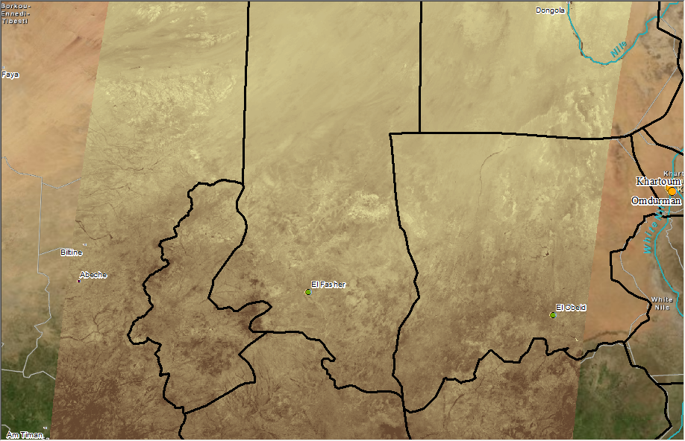
- To remove the inner administrative boundaries for the country of Sudan, you will use a tool in ArcToolbox. Open ArcToolbox → Data Management Tools → Dissolve.
- In the Dissolve dialog box, choose Sudan for Input features. For Output Feature Class, navigate to your Darfur Assign folder and name the new layer: Sudan_bnd.shp. For Dissolve Field, check Country. Click OK.
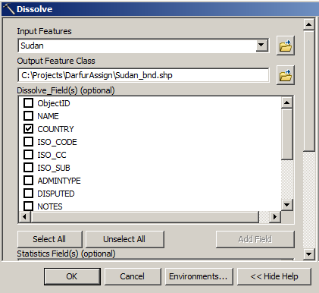

- The new layer should be added to the TOC. Double-click on the Sudan_bnd color symbol. Make the newly created layer hollow with an Outline Width of 2.0. Rename the new layer Sudan Boundary. Remove the original Sudan layer.

Part 7: Create Map Layouts of results in ArcGIS
Step 1: Change to Layout view and create new Data frames.
- From the ArcMap View menu, select Layout View. Wait a minute for it to appear. When you are using esri basemaps and data from ArcGIS online, your application will run a little slower.
- From the File menu, select Page and Print Setup. For size, choose Letter, for Orientation, choose Landscape. Be sure that both Use Printer Paper Settings and Show Printer Margins on Layout are checked. Click OK.
- Because your map will contain three maps, we will need to create two new data frames and move some of the data into them. First rename the “Layers” data frame to Base Map.
- At the top of ArcMap, click on Insert and select Data Frame. Name this data frame Low NDVI 2008. Copy the April 2008 Low Average NDVI from the Base Map data frame and paste it into the Low NDVI data frame.
- Insert another New Data Frame and rename it to High NDVI 2008. Copy the September 2008 High Average NDVI from the Base Map data frame and paste it into the High NDVI 2008 data frame.
- Copy the Basemap Group layer (with the imagery), then Paste it into the two new data frames. Repeat to include World Major Rivers and World Cities into each of these data frames as well. You may have to click the refresh button at the lower left of the layout to improve the display, if it looks mostly black.
- Drag the Boundaries and Places layer from the group layer so that it is displayed above the NDVI image in the both the High and Low NDVI 2008 data frames.
- Copy the Sudan Boundary layer into the two …NDVI data frames. It should now appear in all three data frames. Zoom to the extent of this layer in both of the …NDVI data frames (top layer).
- On your Map Layout page, adjust the size of the data frames and move them so that they look approximately like the example, below. You will fine-tune the arrangement later.
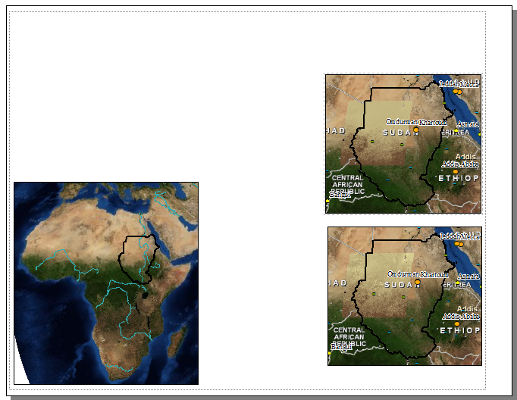

Step 5: Add 10-day rainfall images to map layout.
- Next we need to add two images from the National Oceanic and Atmospheric Administration (NOAA) that shows 10-day rainfall totals over Africa going back to 1999. This imagery, called the RFE 2.0 Rainfall Estimates, may have been already downloaded by your instructor for your use, but can be also be obtained from NOAA’s website at: http://www.cpc.noaa.gov/products /fews/data.shtml#rfe2
- You need to find the rainfall estimate map that corresponds to your NDVI image for April 2008 Low Average NDVI or shortly before. To add this image to your map, go to the Main Menu and click on Insert >> Picture >> navigate to the proper date RFE 2.0 Rainfall Estimate and click Open.
- Repeat this process for inserting an RFE 2.0 Rainfall Estimate that corresponds to the September 2008 High Average NDVI image.
- Go to your Excel graph for January-December 2008. Right-click on the graph and copy the image. Go back to ArcMap and paste the graph into the layout.
- Now adjust all the data frame images and Rainfall Estimate images so they correspond to the image below. The idea is to show rainfall estimates before NDVI values because precipitation patterns greatly influences plant growth.
- Finally, add some basic map elements by going to the Main Menu and clicking on Insert. From there add the following:
- Title for the map
- North arrows for the NDVI images
- Your name and date
- Label which NDVI value image is the lowest and what that value is. Repeat for the image with the highest NDVI value.
- Place a neatline inside the margins.
- Use the World Cities Legend if you use the symbology. Alternatively, you may choose to show only cities over 250,000 and label them as shown below.
- Include the data source information and a Created by …
- Save the image as a PDF file to submit to your instructor. Go to the Main Menu and click on File and Export Map… For “Save As Type”, choose PDF and if possible the Resolution as 300 dpi. Save the file as Darfur_JanDec2008.
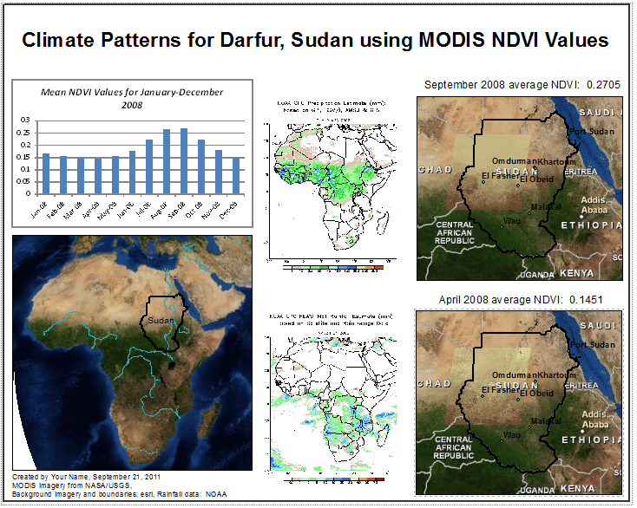

Step 6: On your own, create a map using the imagery from September 2000-2008.
- If needed, open up your ArcMap Darfur project.
- Repeat Parts 6 and 7 as appropriate to create a map that shows the lowest and highest NDVI values for September between the years of 2000 to 2008. Hint: Create two new data frames.
- Use the same GIS layers (basemap group layer) as the previous map and use the same symbology and colors.
Tip: It will help to close (not remove) the Group Layers and data frames that you are not using to keep the TOC from becoming overwhelmingly long.
- Format your final map the same way as before (see image above).
- Save the map as a PDF like before, but name it Darfur2000_2008.

Step 8: Analyzing the Darfur Genocide

Finally, several organizations are now literally watching the Darfur region with satellites to monitor what it going on. One of those organizations is called Eyes on Darfur. Go to their website at http://www.eyesondarfur.org/ and click on The Crisis.

Q9. Read the information provided based on the four tabs: The Crisis, Conflict Analysis, International Response, and Life in Darfur. In the Assignment Worksheet, write up a brief summary (about two paragraphs) of what you learned for each section.

Appendix B. Assignment Worksheet

Name: ______________________________ Due Date: _____________

Class/Time: _______________________

While going through the assignment, fill out the following worksheet and turn into your instructor along with the final two maps.

Step 2: Introduction to NDVI Analysis and Desertification

Q1. How would you explain the difference between a drought and desertification?
________________________________________________________________________________________________________________________________________________________________________________________________________________________________________________________________________________________________________________________________________________________________________________________________________________________________________________________________________________________________________________________________________________________________________________________________________________________________________________________________________________________________________________________________________________________________________________________________________________________________________________________________________________________________________________________________________________________

Q2. Describe the process of collecting NDVI values and why it is used.
________________________________________________________________________________________________________________________________________________________________________________________________________________________________________________________________________________________________________________________________________________________________________________________________________________________________________________________________________________________________________________________________________________________________________________________________________________________________________________________________________________________________________________________________________________________________________________________________________________________________________________________________________________________________________________________________________________________

Step 3: NDVI Analysis for Western Sudan from January-December 2008

Q3. Enter here your mean NDVI values for 2008 and answer the following questions.

 | Mean NDVI Values
January 2008 | 0.1649917636676479
February 2008 | 0.1549764095668307
March 2008 | 0.1506469490556336
April 2008 | 0.1514950571502709
May 2008 | 0.1576514310518821
June 2008 | 0.1770585008262673
July 2008 | 0.2216724818039605
August 2008 | 0.2666259715418846
September 2008 | 0.2704937528501988
October 2008 | 0.2237003195189892
November 2008 | 0.1810674092086585
December 2008 | 0.1622487912323237
What month had the lowest NDVI value?
March 2008

Which month had the highest NDVI value? September 2008

What was the average NDVI value for the months of 2008? 0.19021907

Q5. Equatorial regions of the earth like most of Africa do not have distinct summers and winters like we think of in the United States. Rather, these regions have fairly consistent annual temperatures and distinct wet and dry seasons because of the seasonally migrating tropical thunderstorms called the Intertropical Convergence Zone (ITCZ). Based on the mean NDVI values for 2008, when do you think western Sudan has its wet season and explain why?
________________________________________________________________________________________________________________________________________________________________________________________________________________________________________________________________________________________________________________________________________________________________________________________________________________________________________________________________________________________________________________________________________________________________________________________________________________________________________________________________________________________________________________________________________________________________

Step 4: NDVI Analysis for Western Sudan for September from 2000-2008

Q4. Enter here your mean NDVI values for 2000-2008 and answer the following questions.
What year has the lowest NDVI value? September 2004 0.2607308476093164

What year has the highest NDVI value? September 2007 0.2987115827046415

What is the mean NDVI value for all the years combined? 0.274937729

 | Mean NDVI Values
September 2000 | 0.2629250322245919
September 2001 | 0.2827575976473452
September 2002 | 0.271115789223568
September 2003 | 0.2764961471104606
September 2004 | 0.2607308476093164
September 2005 | 0.2733196398772897
September 2006 | 0.2778891754849205
September 2007 | 0.2987115827046415
September 2008 | 0.2704937528501988

Q7. Based on the data you gathered, analyzed, and created for 2000-2008, did drier conditions begin to develop around the beginning of the genocide? Would it be considered a drought or desertification? Explain.
________________________________________________________________________________________________________________________________________________________________________________________________________________________________________________________________________________________________________________________________________________________________________________________________________________________________________________________________________________________________________________________________________________________________________________________________________________________________________________________________________________________________________________________________________________________________________________________________________________________________________________________________________________________________________________________________________________________

Q8. What other information would be useful to determine if the genocide was influenced by drought?
________________________________________________________________________________________________________________________________________________________________________________________________________________________________________________________________________________________________________________________________________________________________________________________________________________________________________________________________________________________________________________________________________________________________________________________________________________________________________________________________________________________________________________________________________________________________________________________________________________________________________________________________________________________________________________________________________________________

Step 5: Analyzing the Darfur Genocide

Q9. Finally, several organizations are now literally watching the Darfur region with satellites to monitor what it going on. One of those organizations is called Eyes on Darfur. Go to their website at http://www.eyesondarfur.org/ and click on The Crisis. Read the information provided based on the four tabs: The Crisis, Conflict Analysis, International Response, and Life in Darfur. Write up a brief summary of what you learned (about one to two paragraphs for each section).

The Crisis
________________________________________________________________________________________________________________________________________________________________________________________________________________________________________________________________________________________________________________________________________________________________________________________________________________________________________________________________________________________________________________________________________________________________________________________________________________________________________________________________________________________________________________________________________________________________________________________________________________________________________________________________________________________________________________________________________________________________________________________________________________________________________________________________________________________________________________________________________________

Conflict Analysis
________________________________________________________________________________________________________________________________________________________________________________________________________________________________________________________________________________________________________________________________________________________________________________________________________________________________________________________________________________________________________________________________________________________________________________________________________________________________________________________________________________________________________________________________________________________________________________________________________________________________________________________________________________________________________________________________________________________________________________________________________________________________________________________________________________________________________________________________________________

International Response
________________________________________________________________________________________________________________________________________________________________________________________________________________________________________________________________________________________________________________________________________________________________________________________________________________________________________________________________________________________________________________________________________________________________________________________________________________________________________________________________________________________________________________________________________________________________________________________________________________________________________________________________________________________________________________________________________________________________________________________________________________________________________________________________________________________________________________________________________________

Life in Darfur
________________________________________________________________________________________________________________________________________________________________________________________________________________________________________________________________________________________________________________________________________________________________________________________________________________________________________________________________________________________________________________________________________________________________________________________________________________________________________________________________________________________________________________________________________________________________________________________________________________________________________________________________________________________________________________________________________________________________________________________________________________________________________________________________________________________________________________________________________________

Q10. Click on the link for Satellite Evidence on the Eyes on Darfur website to view before and after satellite images of villages destroyed in the Darfur region.

MAKE SURE YOU TURN IN THIS WORKSHEET AND TH E TWO MAPS YOU’VE CREATED!!!

Name: ______________________________ Due Date: _____________
Class/Time: ________________________

Reflection: The Geographic Method

Directions: Throughout the assignment you thought about the geographic method—analyzing a specific region of the world through spatial thinking. Now that you have completed the assignment, reflect and answer the following questions:

What was the geographic question for this assignment? ____________________________________________________________________________________________________________________________________________________________________________________________________________________________________________________________________________________________________________________________________________________________________________________________________________________________________________________________________________________________________________________________________________________________________________________________________________________________________________________________________

What geographic resources did you acquire to complete this assignment?
____________________________________________________________________________________________________________________________________________________________________________________________________________________________________________________________________________________________________________________________________________________________________________________________________________________________________________________________________________________________________________________________________________________________________________________________________________________________________________________________________

In what ways did you explore the geographic data?
____________________________________________________________________________________________________________________________________________________________________________________________________________________________________________________________________________________________________________________________________________________________________________________________________________________________________________________________________________________________________________________________________________________________________________________________________________________________________________________________________

What information did you acquire by analyzing the data?
____________________________________________________________________________________________________________________________________________________________________________________________________________________________________________________________________________________________________________________________________________________________________________________________________________________________________________________________________________________________________________________________________________________________________________________________________________________________________________________________________

How can the information you just learned by applied to a local, regional, and global level?
____________________________________________________________________________________________________________________________________________________________________________________________________________________________________________________________________________________________________________________________________________________________________________________________________________________________________________________________________________________________________________________________________________________________________________________________________________________________________________________________________

